Module 2 – SSIS

SCD1

**Bank Loan Transaction**

**Source Table**

**create** **table** TE_FA_Hrishikesh_BankLoan

(

[LoanNr_ChkDgt] **float**,

[Name] **nvarchar**(255),

[City] **nvarchar**(255),

[State] **nvarchar**(255),

[Zip] **float**,

[Bank] **nvarchar**(255),

[BankState] **nvarchar**(255),

[NAICS] **float**,

[ApprovalDate] **datetime**,

[ApprovalFY] **float**,

[Term] **float**,

[NoEmp] **float**,

[NewExist] **float**,

[CreateJob] **float**,

[RetainedJob] **float**,

[FranchiseCode] **float**,

[UrbanRural] **float**,

[RevLineCr] **nvarchar**(255),

[LowDoc] **nvarchar**(255),

[ChgOffDate] **datetime**,

[DisbursementDate] **datetime**,

[DisbursementGross] **nvarchar**(255),

[BalanceGross] **nvarchar**(255),

[MIS_Status] **nvarchar**(255),

[ChgOffPrinGr] **nvarchar**(255),

[GrAppv] **nvarchar**(255),

[SBA_Appv] **nvarchar**(255)

)

**select** * **from** TE_FA_Hrishikesh_BankLoan

**Target table**

**create** **table** TE_FA_Hrishikesh_BankLoan_Target

(

[LoanNr_ChkDgt] **float**,

[Name] **nvarchar**(255),

[City] **nvarchar**(255),

[State] **nvarchar**(255),

[Zip] **float**,

[Bank] **nvarchar**(255),

[BankState] **nvarchar**(255),

[NAICS] **float**,

[ApprovalDate] **datetime**,

[ApprovalFY] **float**,

[Term] **float**,

[NoEmp] **float**,

[NewExist] **float**,

[CreateJob] **float**,

[RetainedJob] **float**,

[FranchiseCode] **float**,

[UrbanRural] **float**,

[RevLineCr] **nvarchar**(255),

[LowDoc] **nvarchar**(255),

[ChgOffDate] **datetime**,

[DisbursementDate] **datetime**,

[DisbursementGross] **nvarchar**(255),

[BalanceGross] **nvarchar**(255),

[MIS_Status] **nvarchar**(255),

[ChgOffPrinGr] **nvarchar**(255),

[GrAppv] **nvarchar**(255),

[SBA_Appv] **nvarchar**(255)

)

**select** * **from** TE_FA_Hrishikesh_BankLoan_Target

**Update**

**update** TE_FA_Hrishikesh_BankLoan_Target

**set** Name = 'Hrishikesh' **where** LoanNr_ChkDgt = 1000054004

**Aggregate**

**select** **min**(Noemp)**as** min_noemp , **max**(Noemp) **as** max_noemp **from** TE_FA_Hrishikesh_BankLoan_Target

1. **Insert Data from Excel to SQL**

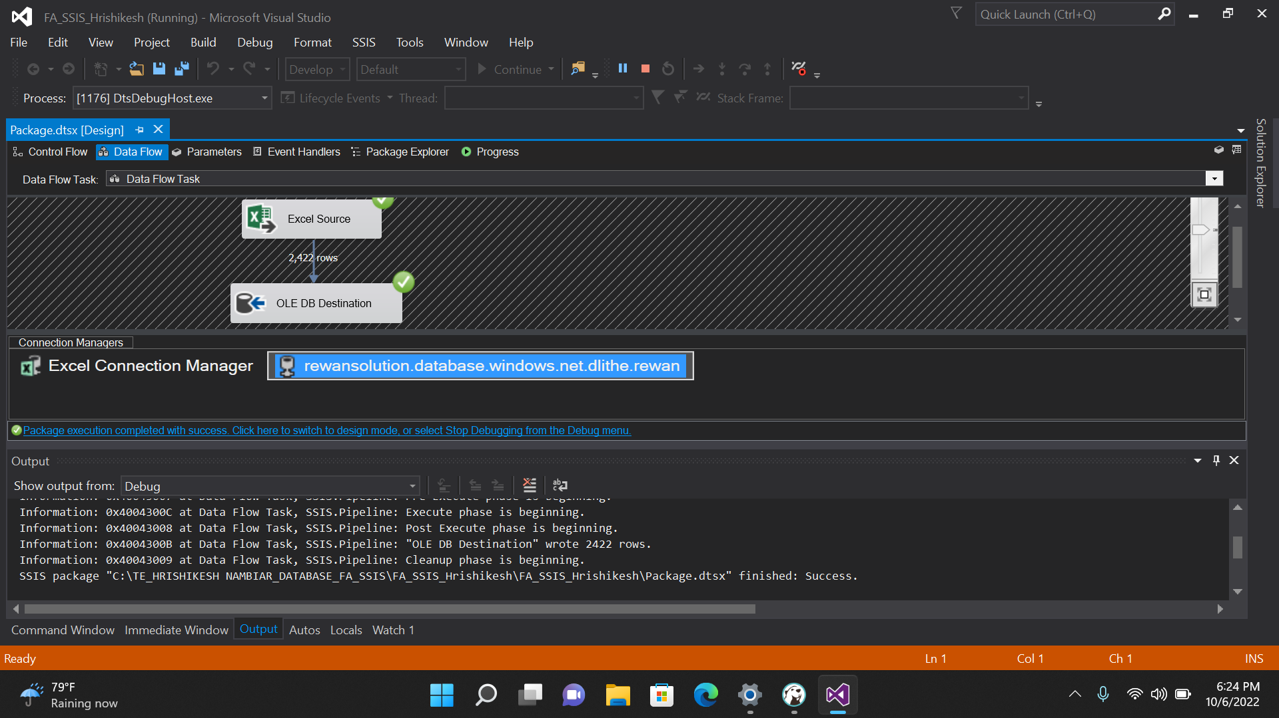

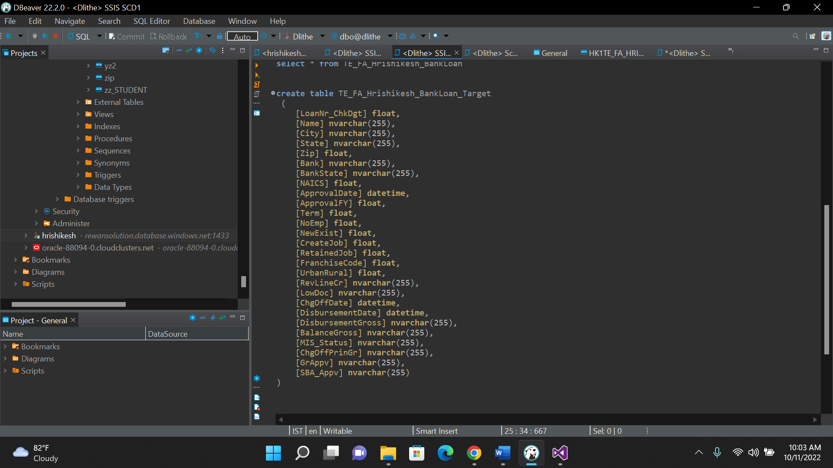

**2.Perform SCD1 Operation**

Update

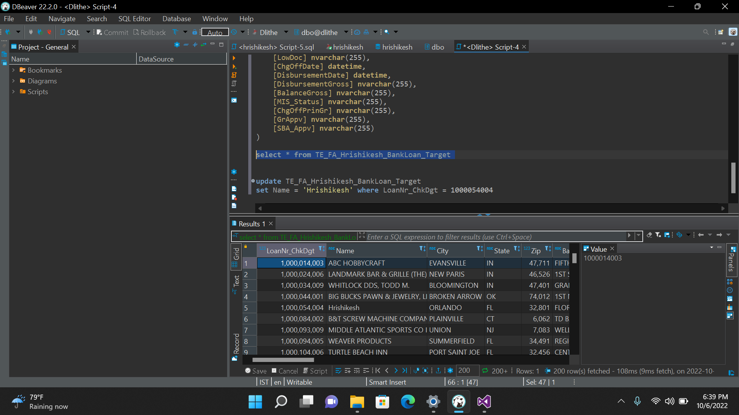

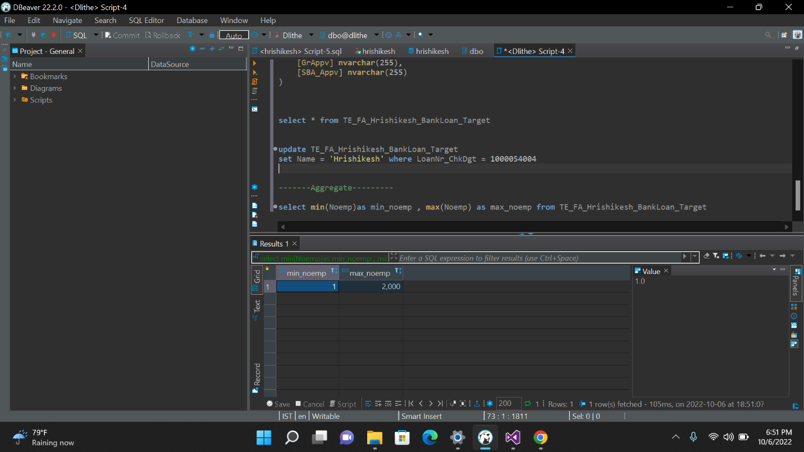Aggregate

SCD2

**Cinema Ticket**

**Source Table**

**Create** **Table** TE_FA_Hrishikesh_CinemaTicket

(

[Film_Type] **nvarchar**(255),

[film_code] **float**,

[cinema_code] **float**,

[total_sales] **float**,

[tickets_sold] **float**,

[tickets_out] **float**,

[show_time] **float**,

[occu_perc] **float**,

[ticket_price] **float**,

[ticket_use] **float**,

[capacity] **float**,

[date] **datetime**,

[month] **float**,

[quarter] **float**,

[day] **float**

)

**select** * **from** TE_FA_Hrishikesh_CinemaTicket

**Target Table**

**Create** **Table** TE_FA_Hrishikesh_CinemaTicket_Target

(

[Film_Type] **nvarchar**(255),

[film_code] **float**,

[cinema_code] **float**,

[total_sales] **float**,

[tickets_sold] **float**,

[tickets_out] **float**,

[show_time] **float**,

[occu_perc] **float**,

[ticket_price] **float**,

[ticket_use] **float**,

[capacity] **float**,

[date] **datetime**,

[month] **float**,

[quarter] **float**,

[day] **float**,

[enddate] **datetime**

)

**select** * **from** TE_FA_Hrishikesh_CinemaTicket_Target

1. **Insert Data from Excel to SQL**

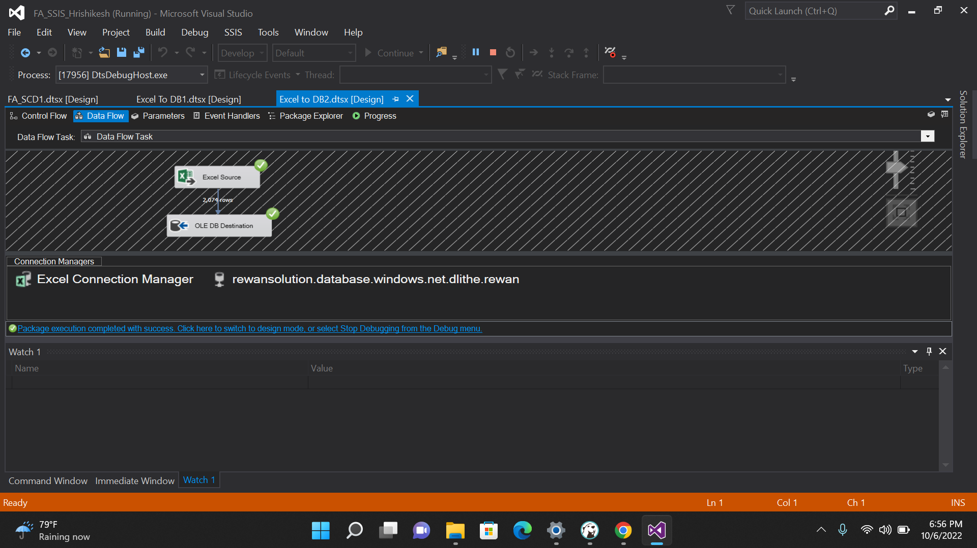

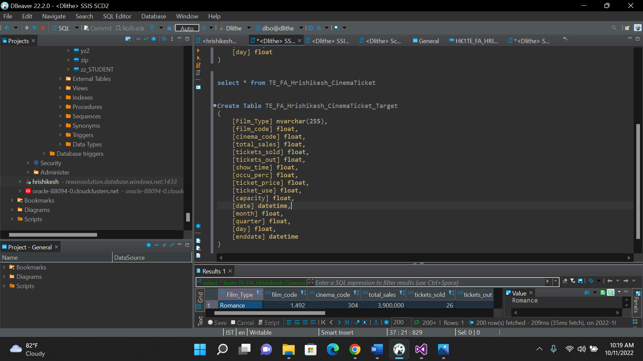

1. 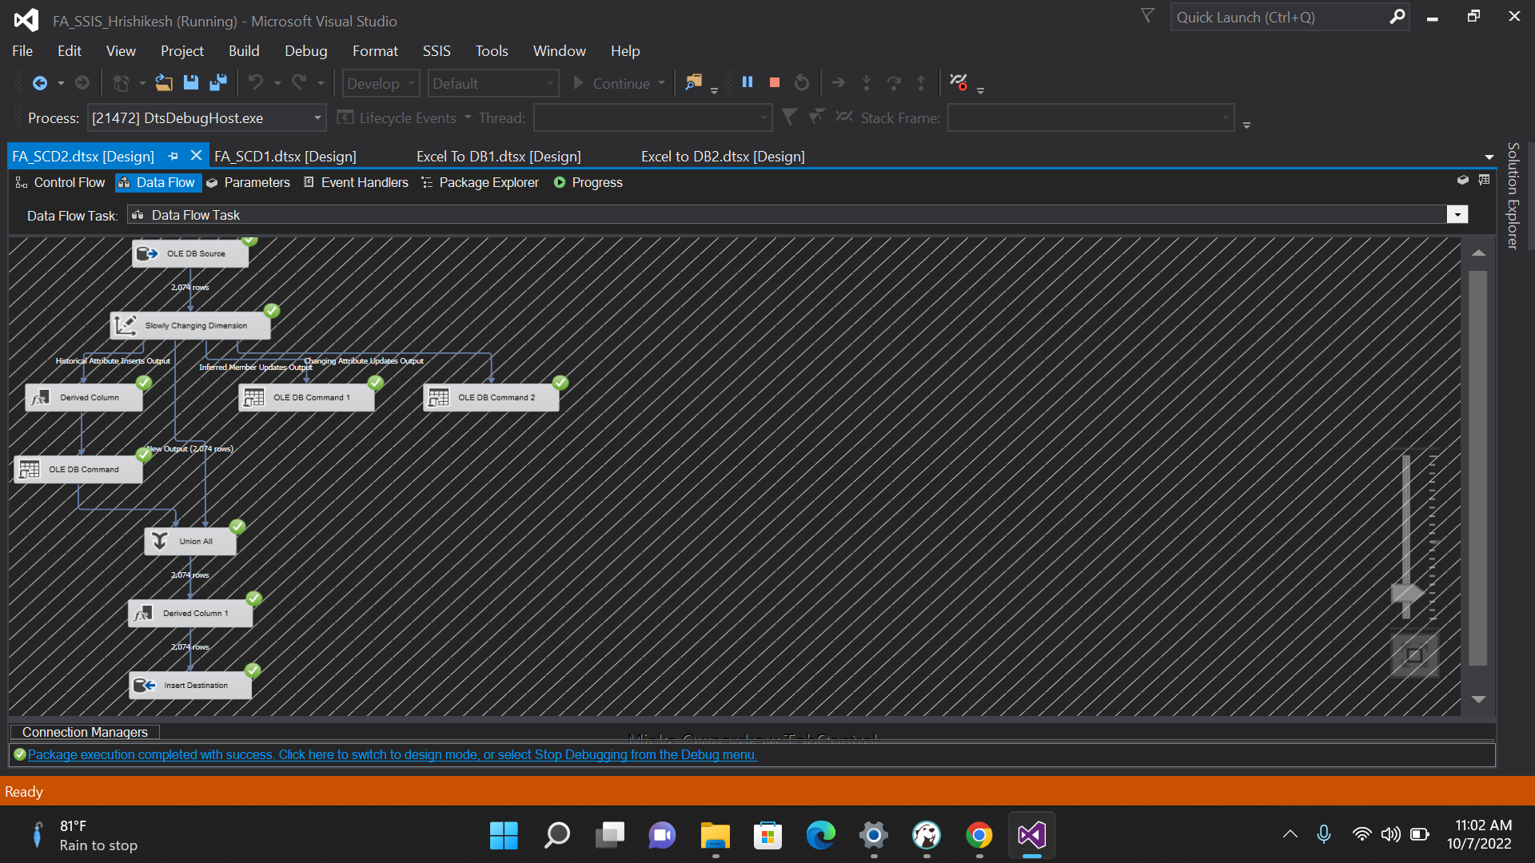**Perform SCD2 Operation**

**Here we get execution result along with historical result.**

Update

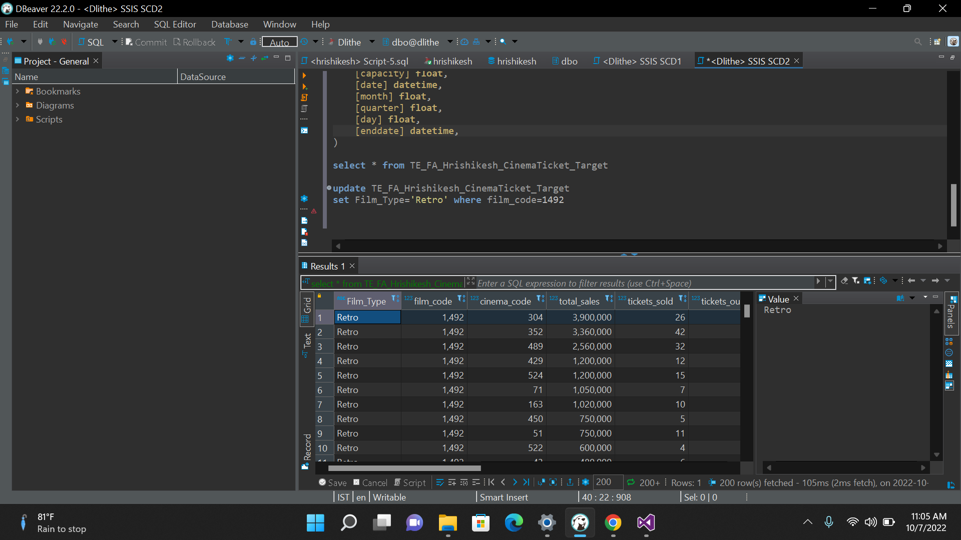

Aggregate